**Name -: Aditya Babaso Birangaddi**

**Roll No -: 47**

**Enrollment No -: 1915770160**

**Practical No 5**

**Sample Question -:**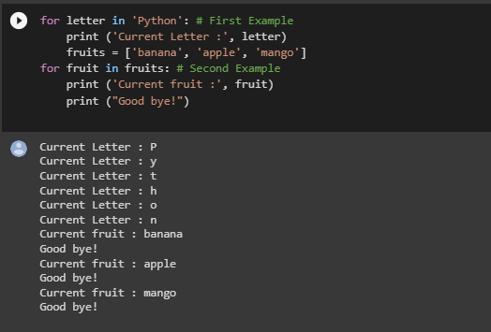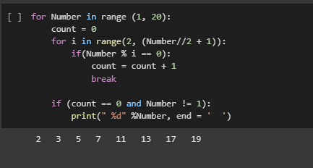

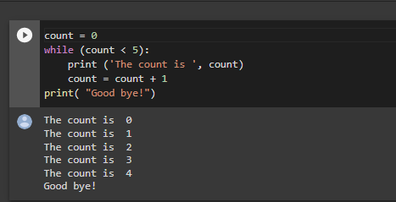

**Q 1] 1. Print the following patterns using loop:** 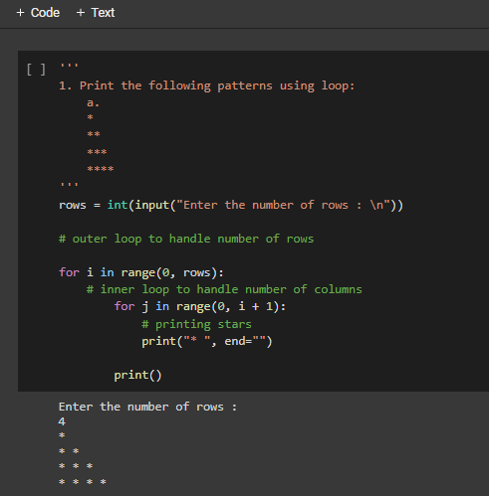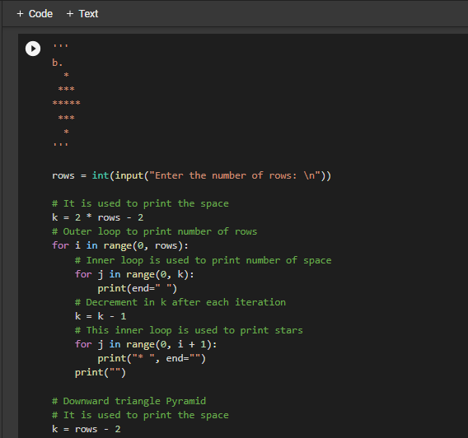

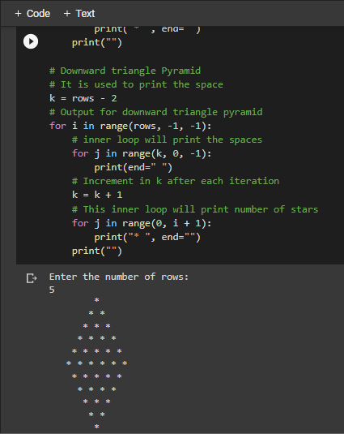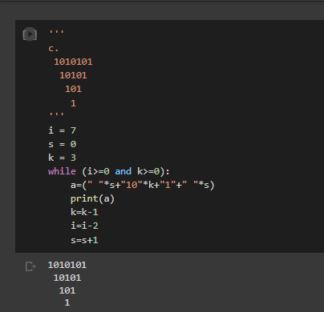

**Q 2] Write a Python program to print all even numbers between 1 to 100 using while loop**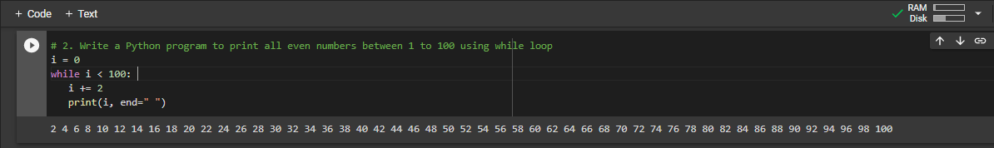

**Q3] Write a Python program to find the sum of first 10 natural numbers using for loop.**

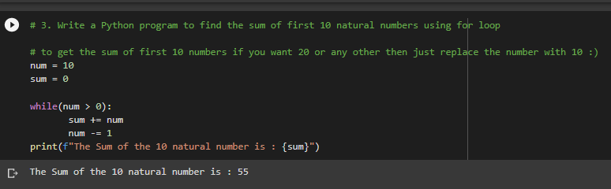

**Q4] Write a Python program to print Fibonacci series.**

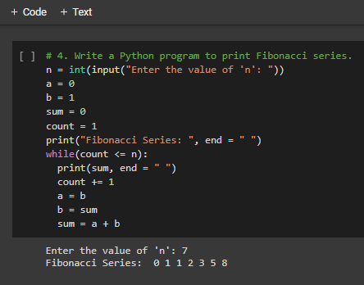

**Q5] Write a Python program to calculate factorial of a number**

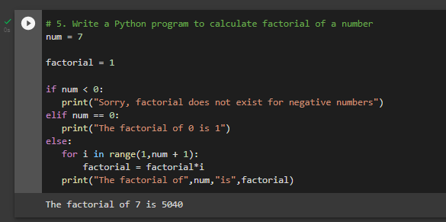

**Q6] Write a Python Program to Reverse a Given Number**

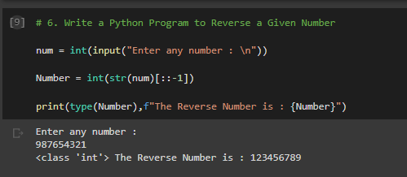

**Q7 ] Write a Python program takes in a number and finds the sum of digits in a number**

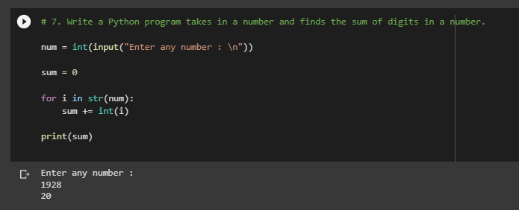

**Q8] Write a Python program that takes a number and checks whether it is a palindrome or not.**

